**Assignment Title:**

Assignment

**Coursework Type:**

Individual/Practical

**Module Name:**

Enterprise Information Systems

**Intake:**

September/November 2019

**Submitted By**

CU ID: 10173183

College ID: 190199

Name: Gauri Shankar Sharma

**Softwarica College in collaboration with**

**Coventry University**

Assessment Submission and Declaration Form

PLEASE COMPLETE SECTIONS IN BLOCK CAPITALS

|  |  |  |  |
| --- | --- | --- | --- |
| **Group work**  If group work ALL student names and IDs must be added below- on behalf of all members; Name................................................... ID......................  Name................................................... ID......................  Name................................................... ID......................  Name................................................... ID......................  Name................................................... ID...................... | | **Surname:** SHARMA | |
| **First Name:** GAURI SHANKAR | |
| **Word Count:** 1071 | |
| **Student number (ID):** 10173183 | | **Attempt:**  FIRST: RESIT: | |
| **Assignment Due Date:** 11/09/2020 | | **Module Code:** STW104KM | |
| **Program Title:** BSC (HONS) COMPUTING | | | |
| **Module Title:** Enterprise Information Systems | | | |
| **Name of Supervisor or Tutor (if applicable):**  Achyut Timsina | | **Individual Work:** | **Group Work:** |
| **Assessment Title and Type (i.e. essay, journal, CD,**  **Dissertation)** | | Assignment |  |
| *I have read the Softwarica College rules and regulations on the submission of academic work and in particular the sections concerning misconduct in assessment, including plagiarism, collusion and cheating. I certify that this assignment is the result of my own (or group) work and contains no unreferenced material from another source and does not contravene any part of the College’s rules and regulations.*  *I acknowledge that in submitting this work I am declaring that I (or my group) are fit to be assessed and that a deferral may not be requested following hand in.*  *I confirm that an electronic version of the item to be assessed where appropriate) is available and will be made available to the College by the specified deadline via Moodle.*  *In respect of group assignments, the submission of this work is made on the basis that all group members are jointly and severally responsible for the work presented for assessment and that by handing in this item for assessment, all group members acknowledge and confirm the statements above and that ALL student names and ID numbers for the group are listed.* | | | |
|  | | | |
| **Student(s) Signature:** | **College Stamp:** | | |

**Table of Contents**

**Introduction** 1

**Use Case Diagram** 2

**Use Case Documentation** 3

**Class Diagram** 4

**Activity Diagram** 6

**Entity Relation Diagram** 8

**Conclusion** 10

**References** 11

# **Introduction**

The main purpose of this report is to build a Project Tracker software solution. A Project Tracker software is a system which tracks all the details of the projects, all the tasks in a project, all the users assigned to the tasks and projects, all the project managers assigned to the projects and the users who are not assigned and are currently free. To find a perfect solution for keeping all the functionality of the system and to make it more flexible, following diagrams of the system will be made which are listed below.

1. Use Case Diagram
2. Use Case Documentation
3. Class Diagram
4. Activity Diagram
5. Entity Relation Diagram

# **Use Case Diagram**

A use case diagram showing all the relevant use cases and actors of the system has been shown below using UML notations. UML stands for Unified Modeling Language and it is a popular diagrammatic notation used for visualizing, constructing, specifying and documenting the components of software or non-software systems (Paradigm, 2020).

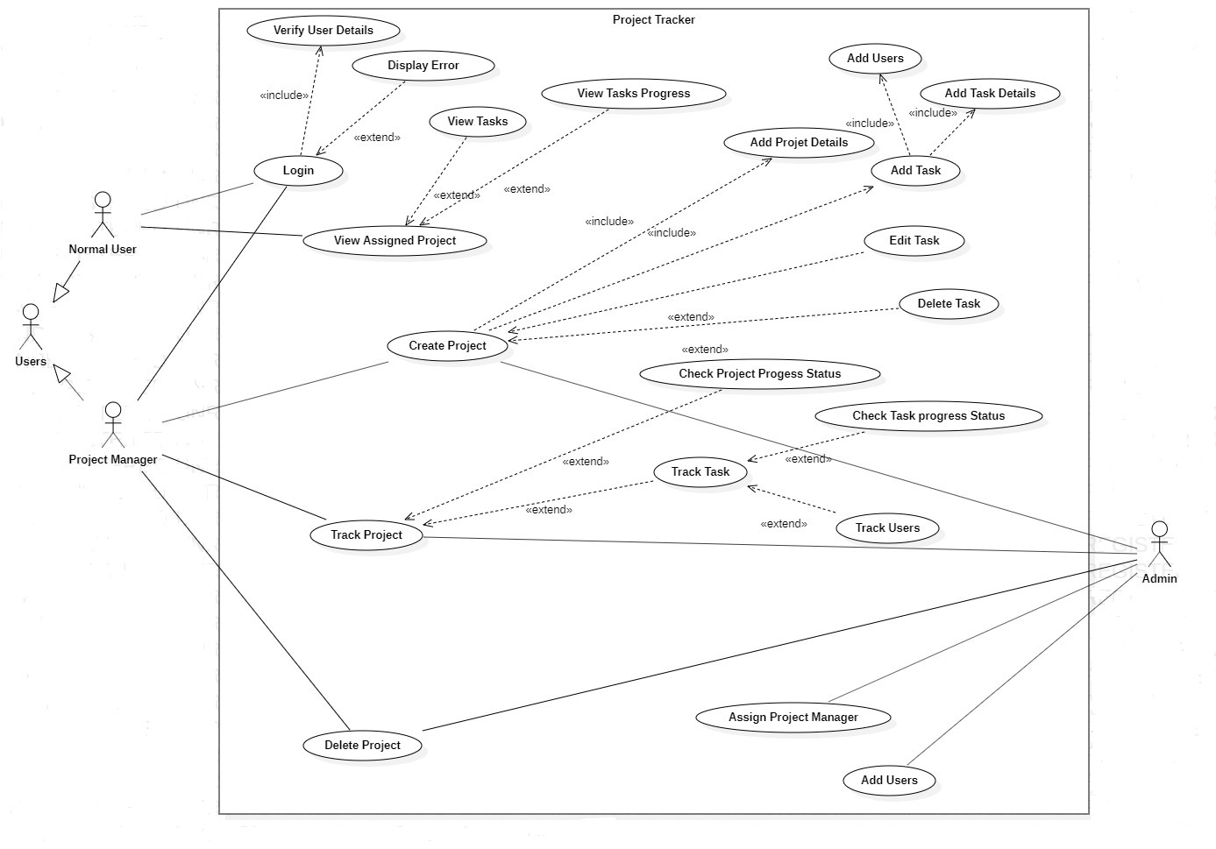

Figure 1: Use Case Diagram

# **Use Case Documentation**

A use case documentation for creating a task by the project manager has been shown below.

Table 1:Use Case Documentation

|  |  |
| --- | --- |
| **Use Case ID:** | ST002 |
| **Use Case Name:** | Create Task |
| **Use Case Description:** | Project Manager creates or edits a new project and add tasks as per requirement and assign it to the users involved in the project. |
| **Actors:** | |
| 1. Project Manager (Primary) 2. Normal User (Primary) 3. Admin (Secondary) | |
| **Pre-conditions:** | |
| 1. User have an account. 2. User is Project Manager. 3. Project Manager homepage is displayed. 4. Project Manager creates a project. | |
| **Basic flow of Events:** | |
| 1. Project Manager logins with ID and password. 2. System verifies user details. 3. System displays Project Manager homepage. 4. Project Manager creates or edits a project. 5. Project Manager fills up project details. 6. Project Manager adds tasks. 7. Project Manager fills up task details. 8. Project Manager adds users. | |
| **Alternative Scenarios:** | |
| 1. User Is not project manager. 2. Project Manager forgot his password. 3. System displays error while verifying detail. 4. Project manager does not create a project. | |
| **Post Conditions:** | |
| 1. System assigns the project and tasks to users that the project Manager added. 2. User start completing the task. | |

# **Class Diagram**

From the natural language analysis of the given scenario, some nouns and verbs has been identified which are then filtered and possible classes, attributes and methods for the system has been identified. This process has been shown below in a table.

Table 2:Natural Language Analysis

|  |  |  |  |
| --- | --- | --- | --- |
| **Unfiltered** | | | |
| **Nouns** | | **Verbs** | |
| Software, Company, Solution, Nepal, Projects, Roof, Element, User, Project Manager, Tasks, Task ID, Time, Milestones, Description, Date, Resources, Name, Skills, Capacities, Information, Project ID, Project Name, Project Description, Percentage. | | Establish, Looking, Manage, Track, Create, Add, Need, Required, Completing, Assigned, Estimated, Hired  Expected, Build, Update. | |
| **Filtered** | | | |
| **Nouns** | | **Verbs** | |
| Projects, User, Project Manager, Tasks, Task ID, Time, Milestones, Description,  Date, Resources, Name, Skills, Project ID, Project Name, Project Description,  Percentage. | | Track, Create, Add, Update. | |
| **Classes** | **Attributes** | | **Methods** |
| Progress Status, Resource, Task, Milestone, Project, User Status, Skill, User Type, Track Project, Login. | id, name, description, estimated time, start date, end date, task completion percentage, password. | | Add, Update, Delete. |

The class diagram for the possible classes, attributes and methods has been shown below.

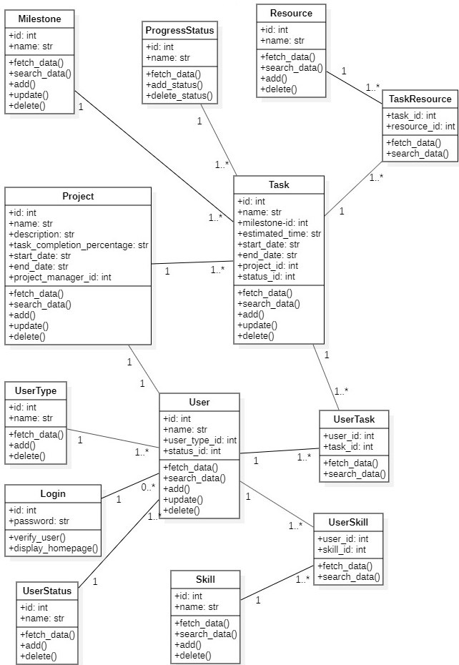

Figure 2: Class Diagram

# **Activity Diagram**

An activity diagram for finding a user in the system, who is not yet assigned to any task and is currently free has been shown below along with the steps.

**Steps:**

1. The user opens the login system
2. User logins with his account
3. System verifies the user’s account
4. System displays the user homepage if his account is verified or displays error if not verified
5. User opens the user page
6. System displays the users list along with the details
7. User searches users by the user status id
8. System verifies the user status id and if the id does not exist, then system displays error. If the id exists but does not matches with the required id, then system displays the users who are assigned. Finally, if the id matched with the required id, then system displays the users who are currently free.

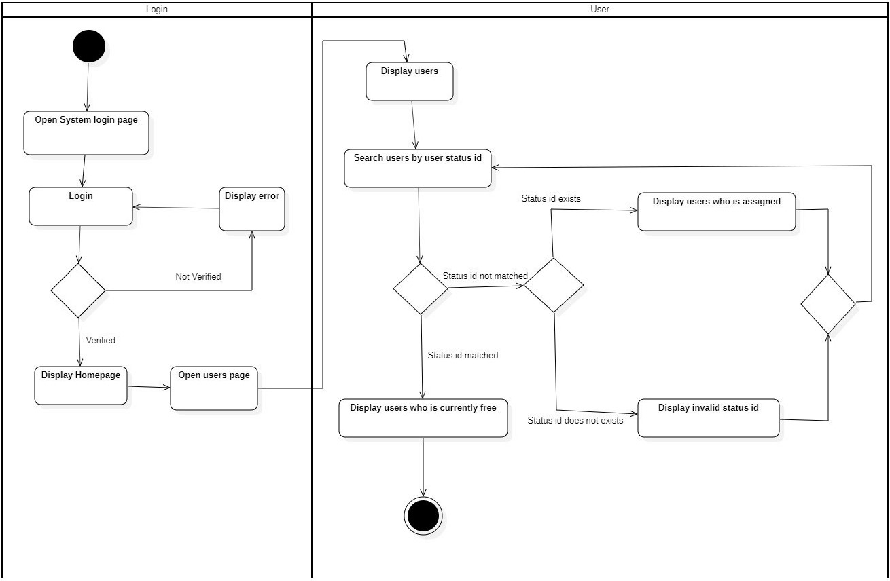

Figure 3: Activity Diagram

# **Entity Relation Diagram**

An entity relationship diagram for this system to identify all relevant entities, attributes, suitable attribute types, primary keys, foreign keys, and cardinalities between entities has been shown below along with all the steps taken to come up with this 3rd form normalized ER diagram using top down approach. Normalization is a method of organizing the tables data in a specific way to reduce data redundancy and insertion, deletion, update anomalies. 1NF, 2NF, 3NF and BCNF are the most commonly used normalization. 3FN table is a table which is in 2FN and [transitive functional dependency](https://beginnersbook.com/2015/04/transitive-dependency-in-dbms/) is removed (Singh, 2020).

**Step 1: Tables for the system (Not normalized)**

* Users table (columns: id, name, skill, user type, user status)
* Tasks table (columns: id, name, users, estimated time, milestone, resource, start date, end date, status)
* Projects table (columns: id, name, description, users, tasks, milestone, task completion percentage, start date, end date)

**Step 2: Tables for the system (Normalized)**

1. A user might be normal at first and then assigned to project manager later. A user also might be free at first and then assigned to the tasks and projects later. Therefore, User table is divided into following tables.

* User Status (id, name), User Type (id, name), Skill (id, name)
* User Skill (user id, skill id)
* User (id, name, user type id, status id)

1. A task might be distributed to multiple users and a project can have multiple tasks and multiple users. A task might be incomplete at first and then might be completed by the users later. Therefore, Task and Project table is divided into following tables.

* Resource (id, name), Milestone (id, name), Progress Status (id, name)
* Task Resource (task id, resource id)
* Task (columns: id, name, milestone id, estimated time, start date, end date, project id, status id), User Task (user id, task id)
* Project (columns: id, name, description, task completion status, start date, end date, project manager id)

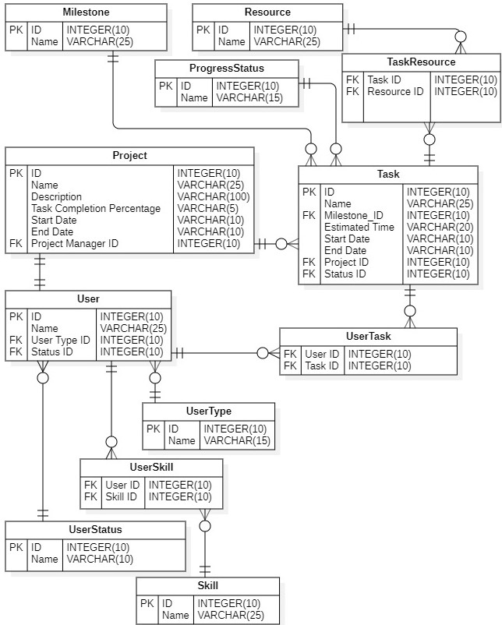

Figure 4: ER Diagram

# **Conclusion**

A perfect solution for the Project Tracker software has been found with the help of Use Case diagram, Use Case Documentation, Class diagram, Activity diagram and ER diagram. Therefore, the system will have all its functionality and will be more flexible to operate without having any problem.

# **References**

Paradigm, V., 2020. *Visual Paradigm.* [Online]   
Available at: https://www.visual-paradigm.com/guide/uml-unified-modeling-language/what-is-uml/  
[Accessed 14 August 2020].

Singh, C., 2020. *Begginners Book.* [Online]   
Available at: https://beginnersbook.com/2015/05/normalization-in-dbms/  
[Accessed 14 August 2020].